If you are Noah, answer the following questions about Neural Networks.

If you are not Noah, draw your best impression of him on the back of this page.

1. What is the name of the model in figure below?

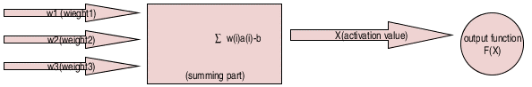

a) Rosenblatt perceptron model

b) McCulloch-pitts model

c) Widrow’s Adaline model

2. The above model is a model of a ______?  
  
 a) Neuron

b) Neural Network

c) Support Vector Machine